Nicole Douglas-Phillips
Consawella’s Crown HairPoetryByNicole

Consawella’sCrown by HairPoetryByNicole:

3 Tips to Keep Your Protective Styling from Doing More Harm Than Good!
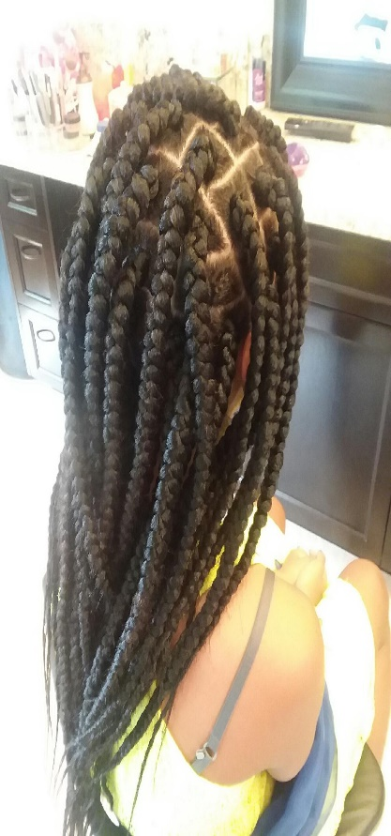
3 Tips to Keep Your Protective Styling from Doing More Harm Than Good
By now the term "protective styling" is a well-known phrase, mostly but not limited to the natural hair community. The actual action of this type of styling has been around for centuries, but the expression is within the last decade.

In an effort to do the age old impossible task of getting our hair to "Submit, Obey, and Do What We Say" the latest wave of the protective style craze has stumbled upon us. Making most of us wide eyed and bushy tailed for the exaggerated legendary stories of how some have left their hair put up in
sew-in weaves, braids, and crochet styles for several months to a year and were able to achieve amazing lengths. How leaving the hair unwashed for long periods of time is best, and adding concoctions of essential oils, kitchen goods, and everything "moisturizing" will award us miraculously with tamed lengthy manes. Not so much. There is a science to hair and its worth learning, but that's a whole other post.
Just to set you up for a more successful foundation on your protective styling journey, I will share 3 simple, but often ignored, tips that will help promote a healthy scalp, prevent hair loss, and encourage healthy hair growth.

1). Whats All the Tension?
There was a theory at one time that the tighter the style, the longer or the more hair growth you will have (insert side eye). This is one of the quickest ways to lose the hair that you have. Tension is directly related to Traction Alopecia, a form of alopecia, or gradual hair loss, caused primarily by pulling force being applied to the hair. This Commonly results from the sufferer frequently wearing their hair in a particularly tight ponytail, weaves, or braids. Traction Alopecia can be fully reversible if detected early enough; however, if it is extensive, the hair loss can be permanent
Just remember "Low to No" tension is best.

2). Low Down Dirty
Most protective styles are meant to stay up and allow for little or no manipulation for a certain time frame. This time frame is usually anywhere from a week to 2 months, in some cases even longer (inserting an additional side eye). When we are in it for the long haul, we mainly want to keep that style looking as fresh as possible for as long as possible... which results in no cleansing, conditioning, and moisturizing. Just a buildup of oils that are attracting dust, and creating a nice spot for fungus, funk, and dried out fragile hair. This then making the whole protective styling mission counterproductive and encouraging even bigger issues concerning our scalps. Protective styles should not be up for over 2 months on healthy hair, and for up to a month with hair that is less than healthy. Cleansing and proper conditioning is very important in not only preserving the integrity of the hair but to maintain balance for our scalp, and not creating hazardous conditions that create infections and hair loss. Also using products that don't just sit on the hair, but Bio-mineral products that penetrate and seal and use natural minerals and botanical proteins. So that the protective style is actually protecting.

3). Love from The Inside Out
When it comes to information on hair growth women are "All Ears". We will go to classes, attend webinars, join groups, read books, and seek " The Secret' by any means necessary. One of the number one tips that we all fail to fully grasp the power of is: DIET. Our diet, what we consume, what we take into our bodies altogether will rear its ugly face on our mane. You know you should be drinking more water, and your hair, even your skin(Scalp) will tell you that. Put down those hot chips, and double fudge cookies with zero nutritional value for your hair, and grab a few of these:
Eggs Provide Protein. ...
Spinach and Other Dark Leafy Greens Provide Iron. ...
Citrus Fruits to Get Your Dose of Vitamin C. ...
Nuts and Seeds for Omega-3 Fatty Acids. ...
Whole Grains to Obtain Biotin. ...
Carrots are Rich in Vitamin A. ...
Avocado Offers Vitamin E.
…And then notice the difference of your protective styling when it’s happening from the inside out.
I hope that these 3 tips are useful in helping you to achieve your hair growth goals and providing some better ways to embark on protective styling. For more tips, hair info, and amazing products sign up for my email list at www.ConsawellasCrown.com
Happy Hair Growth. #ItzPoetic

Consawella's Crown:
Inspiring #FemaleHood♀ through #Art 🖌🖋🖍 #Poetry 📝 #Beauty 💚 #Confidence 👑 Join the movement.
…Also on a mission to bring awareness to domestic violence and its ugly scars #CantCrushMyCrown!
Connect with us @Consawellas_Crown on Instagram
Sign up for the monthly email blast @
www.ConsawellasCrown.com


#ItzPoetic #ConsawellasCrown #HairPoetryByNicole

